**Docker Task -2**

Create a dockerfile, docker-compose file which when executed must display your basic details in the website.

* Files Created



* docker-compose up --build -d

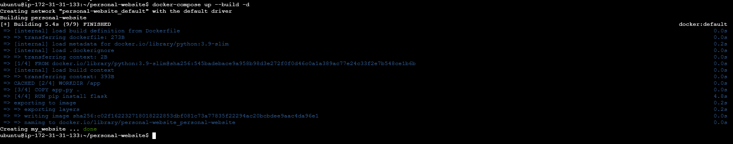

* Website:

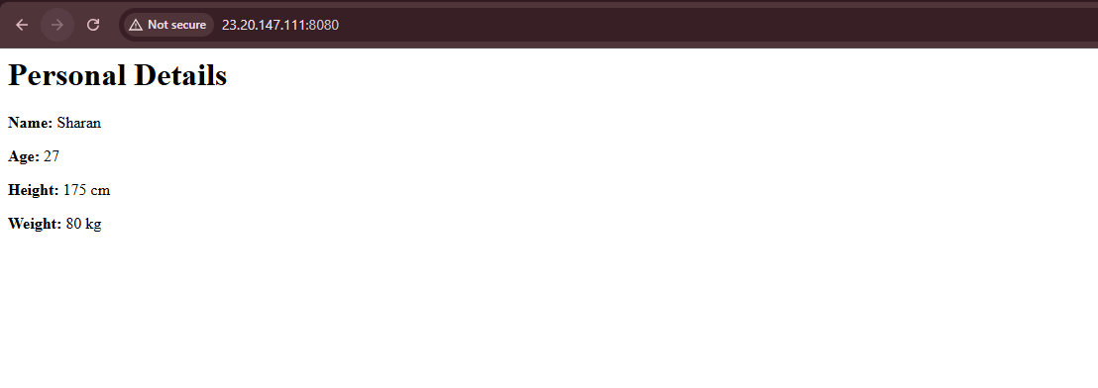

* Running Container



* Docker compose logs

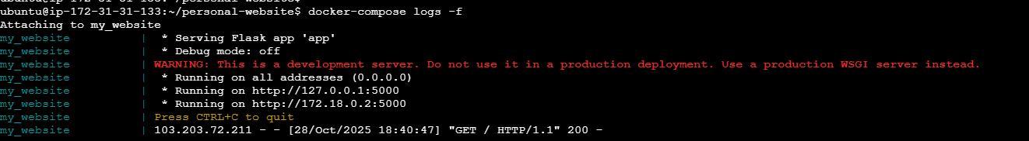

* Docker Compose down

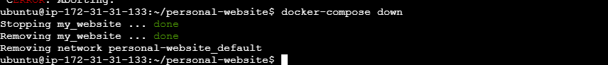

* Website after docker compose down

